Everything in python is object. Every object contains some set of methods.

Commenting in python:

Single line comment – line starting with #

Multi line comment – lines between ‘’’ or “”” three single quotes or double quotes.

6 types of object types in python:

1. Number – integer, flat, hexadecimal or octal
2. String – sequence of characters. Defined in single or double quotes.
3. List - set of elements, similar to array in C program. Element can be set of numbers, strings. Eg: alist = [1,2,3]; blist = [“unix”,”linux”]
4. Tuple – tuple elements are define in (). Eg – atup = ( 1,2,3) Tuple is read only and cannot be modified.
5. Dictionary – contains elements in the form of keys and values. Values are defined in {}; There is no concept of indexing in dictionary.

Eg: addict = {“chap1”:10, ‘chap2’:20, ‘chap3’:30}

1. Set – group of elements of homogenous type. Set elements are always unique. Elements are defined in {}.

It does not have datatypes like int, char, float etc. They are recognized by compiler type language like C. Python is interpreter based language and interpreter categorizes the data type.

Classification objects:

Mutable objects: changable

List, dictionary,

Immutable objects: unchangable

Number, string, tuple

>>> dir(__builtin__) – display list of builtin functions

Frequently used functions:

Input() – capture the user input from keyword(just like scanf in C, read in linux)

Type() – check object type

Dir() – display list of available methods

Help()

Zip() - combine two tuple or list

Id() – display unique identity of object.

Conversion functions:

Str()

List()

Operators:

Arithmetic operator: + - * /

Assignment operators:

No increment and decrement operators

Val =5

Val = val +5 OR val +=5

Val = val * 5 OR val *=5

Relational operators:

==, > ,< ,<=,

Logical operator:

And (&& in C)

Or (|| in C)

Not (! In C)

Conditional operator

In

Special operators

Refer [www.tutorialspoint.com/python3](http://www.tutorialspoint.com/python3)

[www.tutorialcampus.com/examples](http://www.tutorialcampus.com/examples)

cd desktop

git

git --version

git clone <https://github.com/mayurgarg41/Programs.git> GitPrograms

git add programname.py

git commit -m “Intial version”

git push

git status

Library in python:

Library contains set of methods written by someone else.

Eg.

1. Builtin library – installed along with python. Path: C:\Python37\Lib
2. Third party library – Path : C:\Python37\Lib\site-packages. Third party libraries can be downloaded from pypi.org.
3. User defined library

How to include the library

Import libraryname (use in perl)

Eg. Import os

Import time etc

Frequently used builtin libraries:

Os: methods related to OS operations like file, list files.

Sys: methods related to python specific configuration

Datetime: working with date and time

Sysconfig: system config

shutil: shell utilities

zipfile, tarfile,

json: read/write json

csv: working with csv file

logging: log all events,

math: mathematical operations

statistics: all statistical operations

rarfile

sqlite: interacting with sqlite db (default database with python)

subprocess : methods used to invoke system commands (all linux and dos commands)

Steps to install third party library:

Pypi.org has all libraries

2 ways:

1. Pip/easy-install tool in c:/python37/scripts/pip or c:\Anaconda\Scripts

Command: pip install <third party library>

1. Download from pypi

Copy and Extract the file. Navigate to path

Python setup.py install

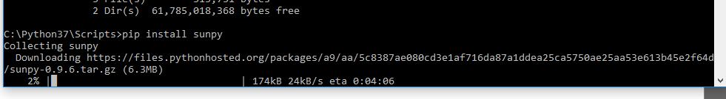

Definition or function or subroutines

Different ways of passing arguments:

1. Fixed arguments
2. Default arguments
3. Keyword arguments
4. variable length argument - any variable prefixed with * becomes tuple